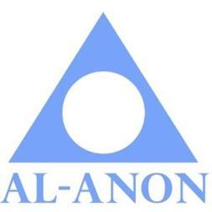

**Area Public Outreach Report Fall 2020 Assembly**

**November 7, 2020**

**Business cards - They have ARRIVED!** The holidays are almost here, it’s a great time to get business cards out to the Police, Fire and First responders in your district. Alternate District Representatives and District PO Coordinators please contact Kathe publicoutreach@ctalanon.org for your supply.

**TV and Radio Public Service Announcements:**  WSO is now sending PSA’s electronically to all Nielsen-tracked TV and radios stations. **Airplay has improved significantly by 130%.** Members are no longer asked to contact radio stations to encourage stations to play the PSA’s or send thank you notes for playing them as it takes additional staff to open mail. However **if you hear a PSA played, contact your District Public Outreach Coordinator or Kathe PublicOutreach@ctalanon.org your feedback is extremely helpful.**

**November 14 - Women’s Virtual Expo** for All of Connecticut!  **It’s FREE!!** Due to the new virtual format thousands will be invited to attend this year.

**Together, Let’s share a message of HOPE with our communities.**

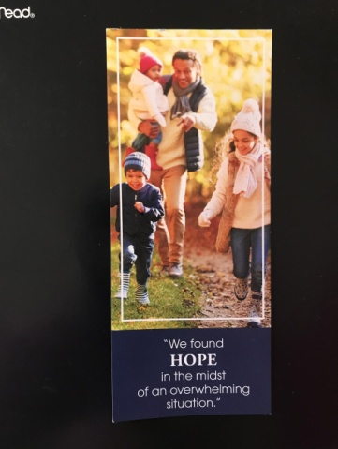

**The 2020 bookmarks are FREE and available to order through the LDC.**

**Our Local Newspapers - The number 1 way we can reach the MOST people.**

* In print or on-line. It’s FREE!
* Keep it simple and put this in your local paper.

**Do you wish the drinking would stop? Al-Anon Family Groups can help.**

Phone and electronic meetings available.

For information visit www.alanon.org or call 1 888 8AL-ANON, (1-888-825-2666)

* Public Outreach has “How To” guides and experienced members available to help.
* The Direct Marketing Association says the average person needs to see an advertisement seven times before they respond to it. Having Al-Anon information printed on a weekly basis is so important for people in our communities to begin to recognize us and know where they can find help.

**Will your district embrace the challenge? How many local papers will print Al-Anon information in your district?** My hope is that all districts can have Al-Anon information printed in their local papers.

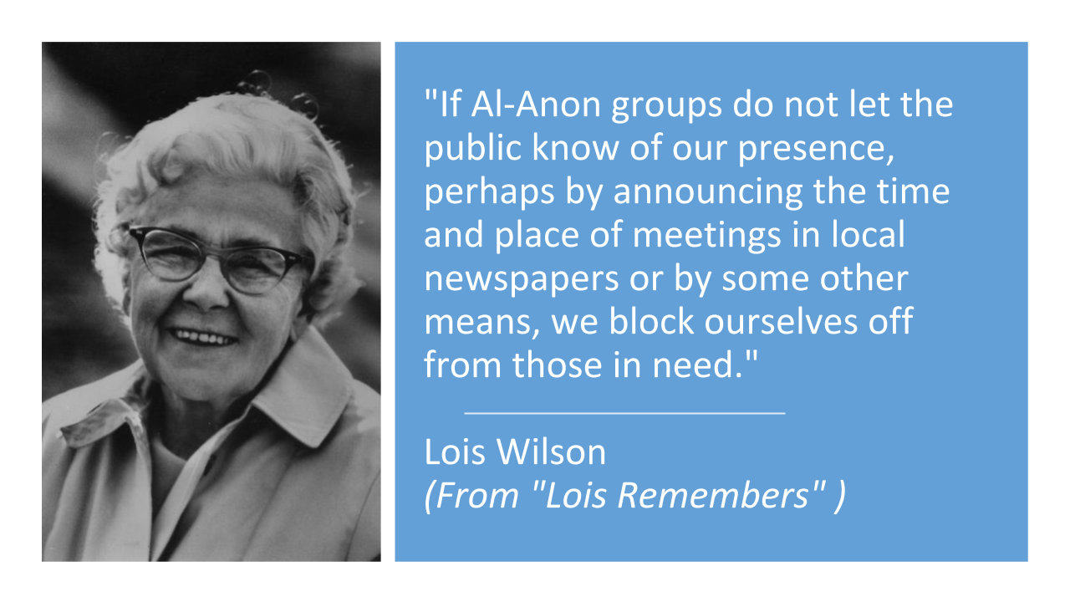

**Thank you** to all who participate in Public Outreach, your service is invaluable!!!

The **next Area Public Outreach meeting is December 4th**

**7:00 pm via Zoom.**

Interested? Contact Kathe LB publicoutreach@ctalanon.org

**New members are always welcome.**