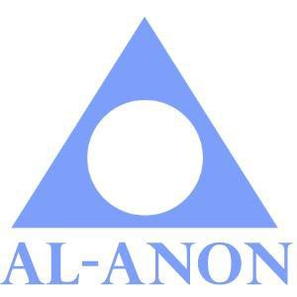 **CONNECTICUT AWSC ASSEMBLY**

**FALL ASSEMBLY – Virtual Format**

**AGENDA**

**November 7, 2020 12: 15 pm**

***Group Representatives’ or Public Outreach Workshops 10:30-11:30 a.m.***

Opening Prayer 12:15 p.m. Elaine M.

Welcome Katie D. & Rosalie L.

Roll Call Taffy P.

Opening Remarks/Announcements Elaine M.

12 Steps, 12 Traditions, 12 Concepts Various members

Secretary’s Report Taffy P.

Treasurer’s Report Jackie B.

Alt. Delegate’s Report Pat S.

Delegate’s Report Marcia M.

**Break – 10 minutes**

|  |  |
| --- | --- |
| **Business: -(20 minutes each)**   * Budget vote   **Reports: (3 minutes each)**   * Alateen Coordinator - Lisa G. * AAPP - Miguel C. * Archives - June C. * AA Events - Justice K. * Board of Directors - Deborah C. * Convention 2021 - Rick L.& Martha N. * Group Records - Kelly D. * LDC Finance Chair - Ron S. * Literature Coordinator – Morgan R. * Phone Service - Marie B. * Public Outreach - Kathe L-B. * Spanish Liaison - Sue D.     **Open Forum/Ask It Basket (20 minutes)**  **Spiritual Speaker Meeting (30 minutes)**  **Closing: Al-Anon Declaration** | **Notes:** |

* Please remember to have your Service Manuals on hand
* If you are on the Agenda and unable make it, please try to send a substitute or contact both the chair and secretary.
* If you are presenting a report, please send an electronic copy to the Area Secretary and Website Coordinator by **Tuesday, November 2, 2020.**
* **All registration forms are due on November 5, 2020**